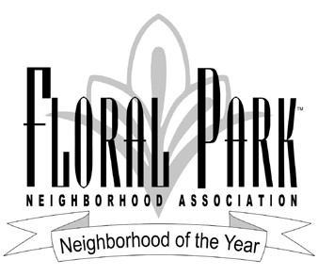
Nomination for FPNA Charitable Donation – 2024
Your Name: _______________________________________________________
Your Address: _____________________________________________________
Your Nominated Non-Profit / 501(c)(3) organization:
_________________________________________________________________
What do they do? __________________________________________________
__________________________________________________________________
Do they provide services in Santa Ana? ________________________________

Why should they receive a donation from FPNA? ________________________
___________________________________________________________________
___________________________________________________________________
Their contact information including phone numbers, physical, and web address:
___________________________________________________________________
____________________________________________________________________
Nomination form must be submitted to giving@floralpark.com by January 31, 2024

